**Process Book -**

**Boxoffice 360**

**Team Details**

Project Repository: <https://github.com/anirajk/boxoffice360>

Aniraj Kesavan

[aniraj@cs.utah.edu](mailto:aniraj@cs.utah.edu)

u0996550

Ashwini Janamatti

[ashwinijanamatti@gmail.com](mailto:ashwinijanamatti@gmail.com)

u0996548

**Overview and Motivation**

By the end of the 1880s, the introduction of lengths of celluloid photographic film and the invention of motion picture cameras, which could photograph an indefinitely long rapid sequence of images using only one lens, allowed several minutes of action to be captured and stored on a single compact reel of film. Some early films were made to be viewed by one person at a time through a "peep show" device such as the Kinetoscope. Movies have grown

from paltry beginnings to complex multi year projects producing highest fidelity pictures using

3-D Stereoscopic projection etc.

There is a staggering amount of movies made over generations and there is no good visualization tool that exists today which captures the essence of the evolution of movies, nor does a solution exist which can visualize movie data per year with the ability to sort and filter based on attributes of a movie. Solutions such as IMDB exists, but they are better suited to extract more information than general exploration

In this project, we plan to visualize a well curated dataset of over 5000 movies. We pre-processed the data using imdbs apis to enhance information and visualize both the holistic evolution of movies as well as enhanced views of movies released every year.

**Related Work**

The closest related work that we have seen that inspired us to develop the per year visualisations are the new and improved google movie specific search results, attaching screenshots here:

**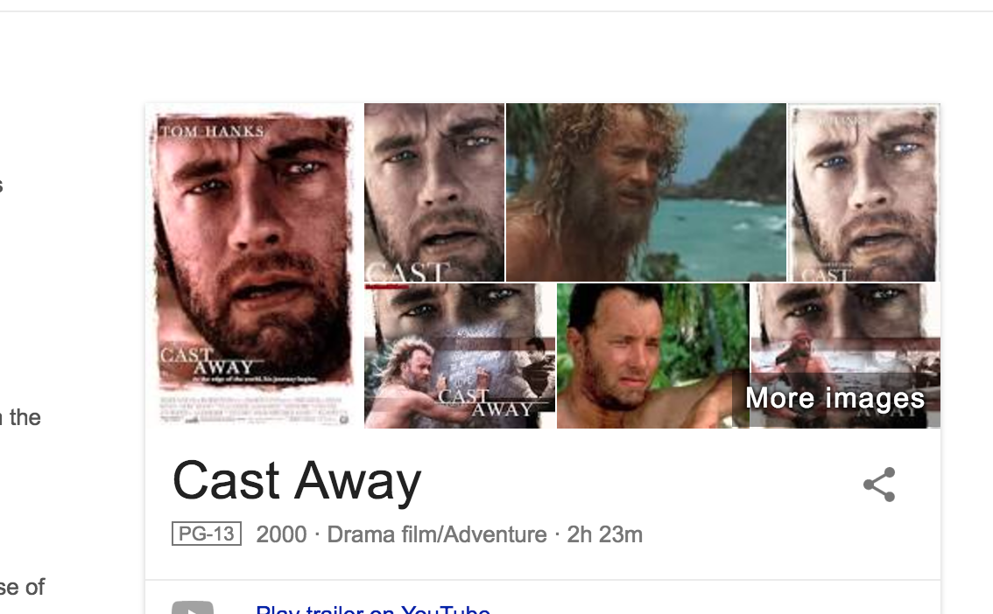**

**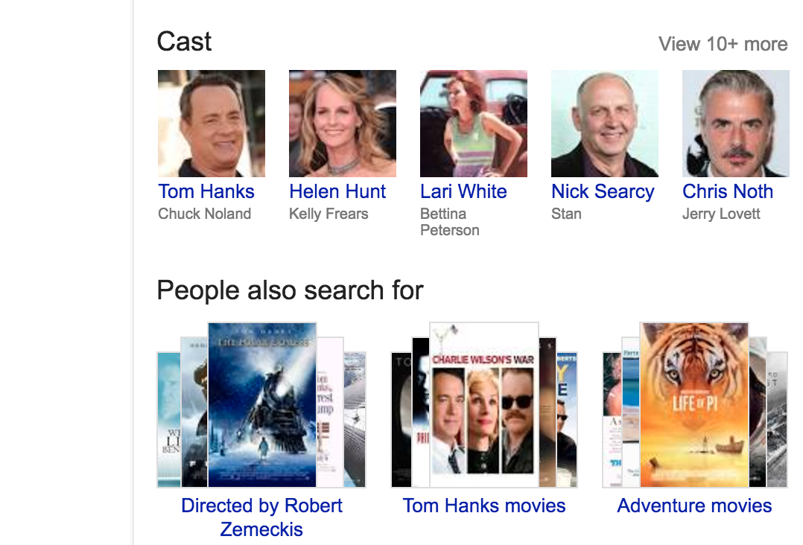**

**Questions**

Through visualizing the data on movies, we are trying to answer the following questions:

* ?
* ?
* ?

By answering these questions, we will be able to get a big picture of trends in terms of evolution of movies overe decades, how well movies have performed in their release year in terms of boxoffice results, current relevance (likes in social media etc), duration, ratings etc.

The selective exploration of movies released every year also helps in diving more into the details and helping the user make informed opinions.

**Data**

* Our primary source of data was a curated dataset of over 5000 movies that we researched and found at kaggle.com
  + <https://www.kaggle.com/deepmatrix/imdb-5000-movie-dataset>
* Since people identify movies best with their posters, we wanted to include movie posters in our visualization, but we didn’t want to store over 5000 images since that would take up serious amounts of space and hamper client loading performance. So we made use of a dynamic api provided by wemakesite creator Martin Ivanov. The api is available at
  + <http://imdb.wemakesites.net/api/>
* The api returned json results like the following:
  + {    
       **"status"**:"success",  
       **"code"**:200,  
       **"message"**:"ok",  
       **"data"**:{    
          **"id"**:"tt0115956",  
          **"type"**:"title",  
          **"title"**:null,  
          **"year"**:null,  
          **"description"**:"The pilot of a rescue copter, Captain Karen Walden, died shortly before her helicopter crew was rescued after it crashed in Desert Storm. It first  Written byBrian W Martz <B.Martz@Genie.com>",  
          **"certificate"**:"",  
          **"duration"**:"1h 56min",  
          **"released"**:"1996-07-12",  
          **"cast"**:[    
             "Denzel Washington",  
             "Meg Ryan",  
             "Lou Diamond Phillips",  
             "Michael Moriarty",  
             "Matt Damon",  
             "Bronson Pinchot",  
             "Seth Gilliam",  
             "Regina Taylor",  
             "Zeljko Ivanek",  
             "Scott Glenn",  
             "Tim Guinee",  
             "Tim Ransom",  
             "Sean Astin",  
             "Armand Darrius",  
             "Mark Adair-Rios"  
          ],  
          **"genres"**:[    
             "action",  
             "drama",  
             "mystery",  
             "thriller",  
             "war"  
          ],  
          **"directors"**:[    
      
          ],  
          **"writers"**:[    
      
          ],  
          **"image"**:"https:\/\/images-na.ssl-images-amazon.com\/images\/M\/MV5BMTMwNDk0NjUzOF5BMl5BanBnXkFtZTcwNjcxODIyMQ@@.\_V1\_UY268\_CR2,0,182,268\_AL\_.jpg",  
          **"review"**:{    
             **"text"**:"Courage under fire was an okay movie, the story was good enough to keep me : 6 out of 10.",  
             **"rating"**:"7\/10"  
          }  
       }  
    }

**Data Processing**

While our primary data was found from a reputable source, we still found some duplicate entries among the data source. In order to make it pluggable with any data set, we decided to implement our own logic to de-duplicate entries. This is done before any processing.

We were initially hitting the imdb api asynchronously whenever we wanted to load poster images, this involved a lot of network transfer. We decided we could pre-fetch the image url and tack that on to the data, so we did a run of data enhancement to enrich the data.

While enriching the data, we also found that there are other useful information from the response that was otherwise missing from our primary data source, so we merged our primary data with the newly found data.

**Exploratory Data Analysis**

**Design Evolution**

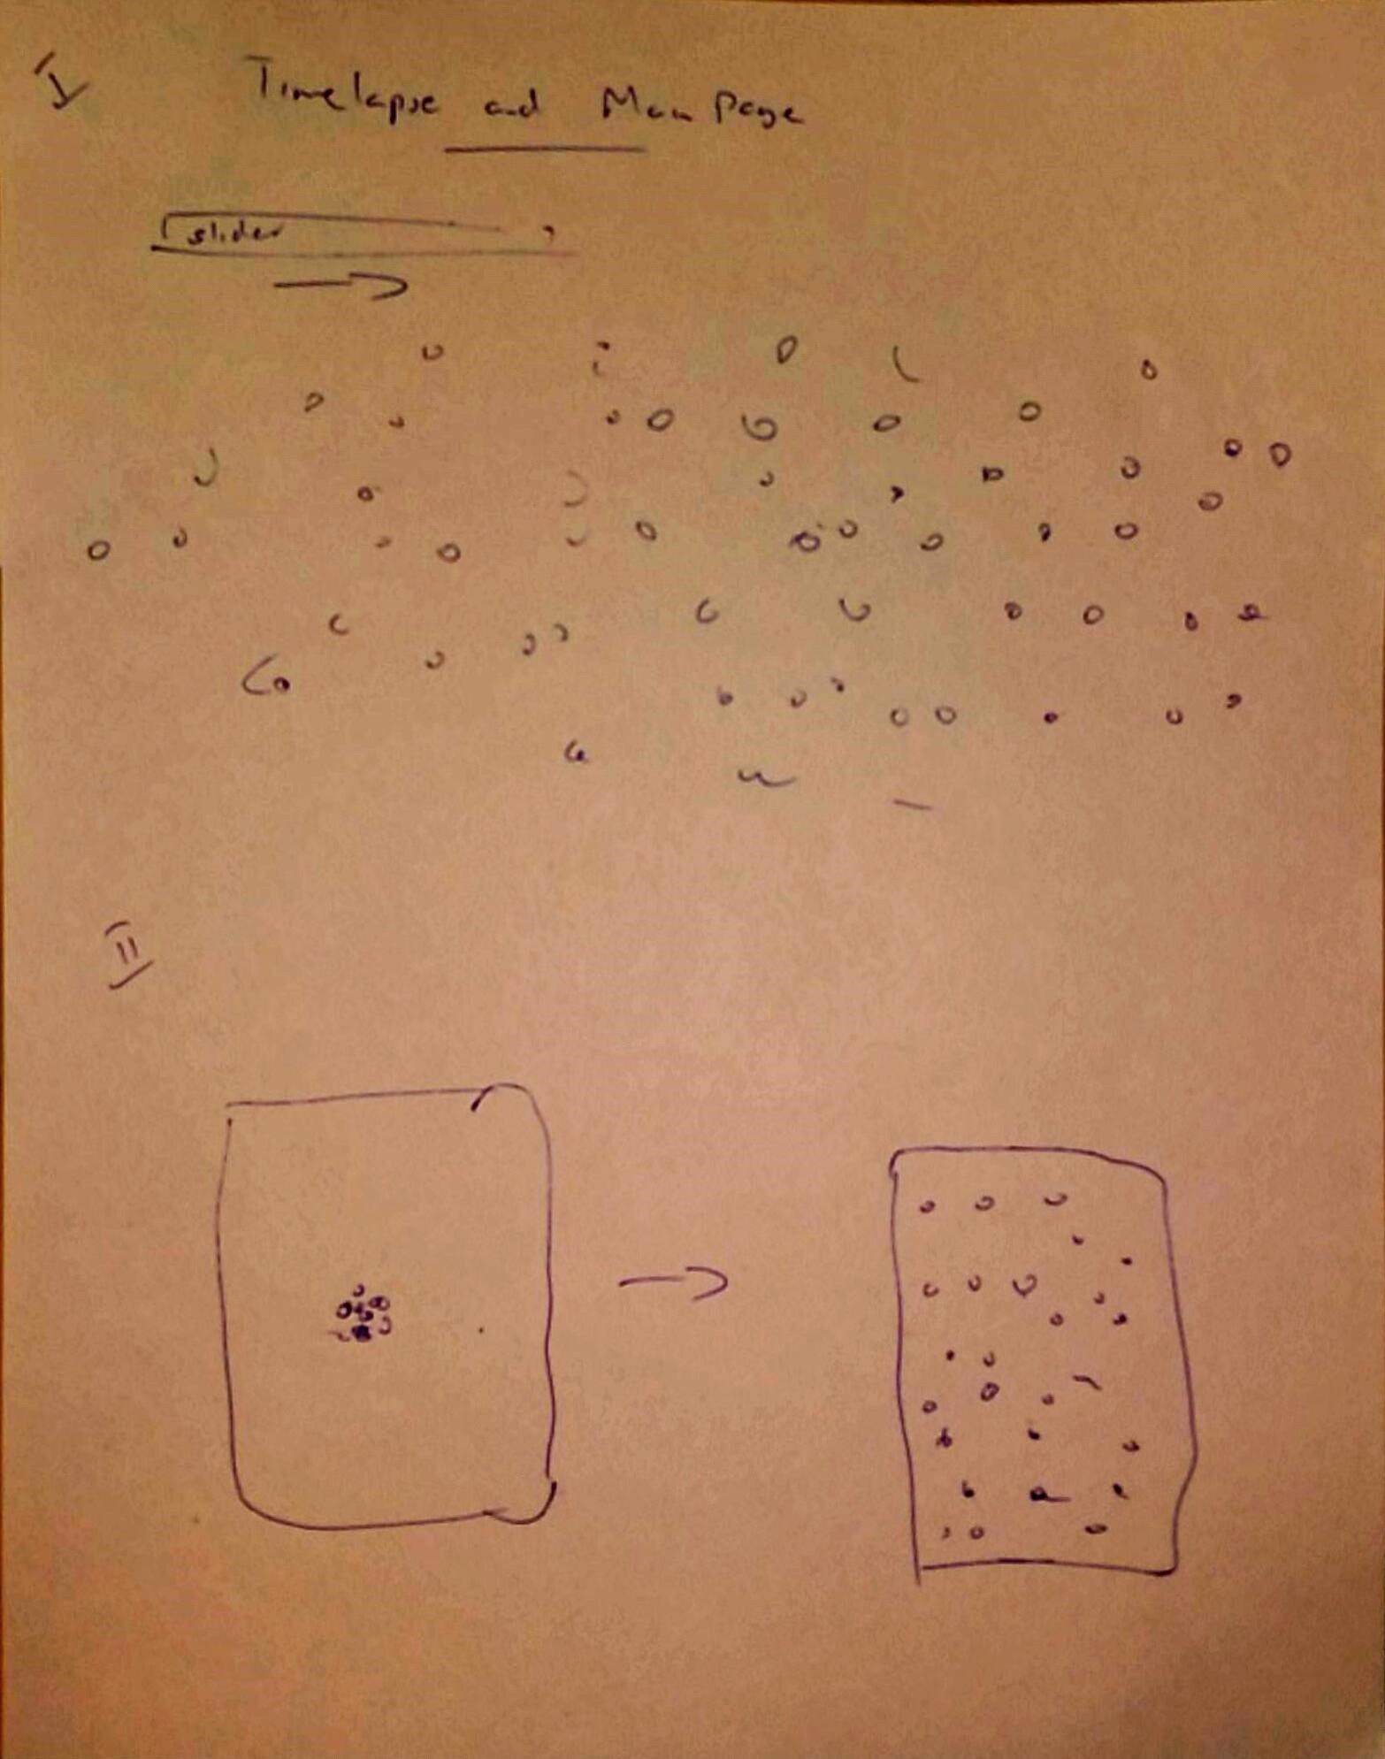

../../../private/tmp/boxoffice360/process_book/timelapse_2.pdf

../../../private/tmp/boxoffice360/process_book/year_sketch_1.pdf





**Must-Have features**

**Optional features**

**Implementation**

1. **Timelapse**
2. Per Year.

**Evaluation**